Contents
SERVLET BASICS 1
Servlet LifeCycle 1
SERVLET LISTENERS 2
Introduction 2
ServletContextListener 3
Session Listener 3
Declare the Listeners in the Deployment Descriptor 4
SERVLET FILTERS 5
Introduction 5
Illustration: How Servlet Container invokes Filters 5
Filter Capabilities 5
Applications of Filter 6
Filters under RequestDispatcher 6
Writing a Filter 6
Initialization Parameters 7
REQUEST DISPATCHER 8
WEB DEPLOYMENT DESCRIPTOR 9
NEW FEATURES – SERVLET 2.4 13
SERVLET FAQ 14
GenericServlet & HttpServlet 14
getServletInfo 14
Why setContentType() should be called before getWriter() 14
init(), init(ServletConfig) & destroy() 14
Head Request in Servlet 15
Thread Safety 15

SERVLET BASICS

Servlet LifeCycle

Servlets follow a three-phase life: initialization, service, and destruction, with initialization and destruction typically performed once, and service performed many times. The container can create a servlet instance at container startup (by setting the load-on-startup tag to a non-zero value) or it can delay it until the servlet is needed to service a request.

By default a Servlet is multi-threaded, meaning that typically only one instance of a Servlet is loaded by a JSP container at any given time.

Initialization is done once, and each request after that is handled concurrently by threads executing the Servlet's service() method.

The Servlet interface defines the destroy() method to correspond to the destruction life cycle phase. Each time a Servlet is about to be removed from use, a container calls the destroy() method, allowing the Servlet to gracefully terminate and tidy up any resources it might have created.

public void init(ServletConfig config) throws ServletException // ← Called once
public void service(ServletRequest req, ServletResponse res) throws ServletException, IOException
public void destroy() // ← Called once

Case 1: Service method (Not Implemented): The service() method is automatically called by the web server when a request is made. This method determines what kind of HTTP request(POST/GET/HEAD/DELETE) and automatically dispatches the request to the appropriate doXXX() method. This is the behaviour if the service method is not implemented.
public class HelloServlet extends HttpServlet
{
public void doGet(HttpServletRequest req, HttpServletResponse res) throws ServletException, IOException
{
res.setContentType("text/html");
PrintWriter out = res.getWriter();
out.println("<html><body><b>doGet Hello World!!</b></body></html>");
out.close();
}

public void doPost(HttpServletRequest req, HttpServletResponse res) throws ServletException, IOException
{
res.setContentType("text/html");
PrintWriter out = res.getWriter();
out.println("<html><body><b>doPost Hello World!!</b></body></html>");
out.close();
}
}

In case of a Get request, An HTML page will display doGet Hello World!!
In case of a Post request, An HTML page will display doPost Hello World!!

Case 2: Service method (Implemented)
If both the service() and the doXXX() methods are implemented. Then, the service() method must call the doXXX() based on the method(GET/POST etc,). Else, the doXXX will not be invoked. Example, given below.

public class HelloServlet extends HttpServlet
{
public void service(HttpServletRequest req, HttpServletResponse res) throws ServletException, IOException
{
}

public void doGet(HttpServletRequest req, HttpServletResponse res) throws ServletException, IOException
{
res.setContentType("text/html");
PrintWriter out = res.getWriter();
out.println("<html><body><b>doGet Hello World!!</b></body></html>");
out.close();
}

public void doPost(HttpServletRequest req, HttpServletResponse res) throws ServletException, IOException
{
res.setContentType("text/html");
PrintWriter out = res.getWriter();
out.println("<html><body><b>doPost Hello World!!</b></body></html>");
out.close();
}
}

a) An HTML page displaying doGet Hello World!!
b) A blank HTML page
c) An HTML page displaying doPost Hello World!!
d) An error message

CORRECT ANSWER : b
A blank HTML page will be displayed. The class javax.servlet.HttpServlet implements the service() method, so that it calls the doGet or doPost method according to the HTTP Request (GET or POST respectively) used to invoke the servlet. If we override the service() method in our Servlet class(which extends the HttpServlet class), then, the default functionality of the service() method is lost, and the doGet() or doPost() method is not invoked. Thus in the above case service() method will be called which does nothing.

SERVLET LISTENERS

Introduction
- Servlet Context Events
  - javax.Servlet.ServletContextListener (LifeCycle)
  - javax.Servlet.ServletContextAttributesListener (Attributes Added/Removed/Replaced)
- Http Session Events
  - javax.Servlet.http.HttpSessionListener (LifeCycle)
  - javax.Servlet.http.HttpSessionAttributesListener (Attributes Added/Removed/Replaced)

An interesting point is that there can be multiple listener classes listening to each event type and the Web application developer has the flexibility to define the order the event listener objects are invoked. (The order you define the listener classes in web.xml does matter. They will be executed in the order you specify.)

The container manages the lifecycle of event listeners. It is the containers responsibility to instantiate each of the listener classes in a Web Application before the execution of the first request into the Web Application. Also, each of the listener classes must be referenced until the Web Application services the last request.

ServletContextListener

To write an application lifecycle event listener that executes when the servlet context is created and destroyed, write a Java class that implements the javax.Servlet.ServletContextListener class. This class has two methods with the following signatures (taken from the JavaDocs):

void contextDestroyed (ServletContextEvent sce)
Notification that the Servlet context is about to be shut down.

void contextInitialized (ServletContextEvent sce)
Notification that the Web Application is ready to process requests.

To execute some code when the attributes of the ServletContext object has been modified, write a Java class that implements the javax.Servlet.ServletContextAttributesListener interface. This interface defines three methods with the following signatures.

void attributeAdded (ServletContextAttributeEvent scab)
Notification that a new attribute was added to the servlet context.

void attributeRemoved (ServletContextAttributeEvent scab)
Notification that an existing attribute has been removed from the servlet context.

void attributeReplaced (ServletContextAttributeEvent scab)
Notification that an attribute on the servlet context has been replaced.

Session Listener

To receive lifecycle notifications for HttpSession objects write a Java class that implements the javax.Servlet.http.HttpSessionListener interface. This interface defines two methods and their signatures are:

void sessionCreated (HttpSessionEvent se)
Notification that a session was created.

void sessionDestroyed (HttpSessionEvent se)
Notification that a session was invalidated.

To receive notifications that the attributes of an HttpSession object have been modified implement the javax.servlet.http.HttpSessionAttributesListener interface. This interface defines three methods and their signatures are (taken from the JavaDocs):

void attributeAdded (HttpSessionBindingEvent se)
Notification that an attribute has been added to a session.

void attributeRemoved (HttpSessionBindingEvent se)
Notification that an attribute has been removed from a session.

void attributeReplaced (HttpSessionBindingEvent se)
Notification that an attribute has been replaced in a session.

Declare the Listeners in the Deployment Descriptor

<?xml version="1.0" encoding="ISO-8859-1"?>

<!DOCTYPE web-app
PUBLIC "-//Sun Microsystems, Inc.//DTD Web Application 2.3//EN"
"http://java.sun.com/j2ee/dtds/web-app_2_3.dtd">

<web-app>

<!-- Define application events listeners -->
<listener>
<listener-class>
com.listeners.MyContextListener
</listener-class>
</listener>

<listener>
<listener-class>
com.listeners.ServletContextAttribListener
</listener-class>
</listener>
….
….
</web-app>

SERVLET FILTERS

Introduction
- A filter is an object that can transform a request or modify a response.
- Filters are not servlets; they don't actually create a response.
- Filters are preprocessors of the request before it reaches a servlet, and/or postprocessors of the response leaving a servlet.

Illustration: How Servlet Container invokes Filters

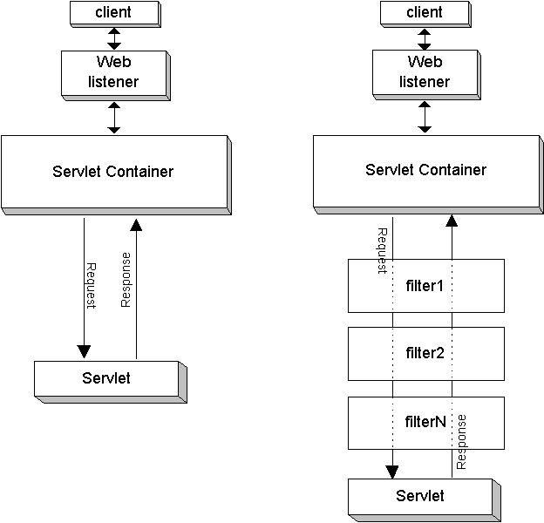

If there are two filters, for example, the key steps of this mechanism would be as follows:
- The target servlet is requested. The container detects that there are two filters and creates the filter chain.
- The first filter in the chain is invoked by its doFilter() method.
- The first filter completes any preprocessing, then calls the doFilter() method of the filter chain. This results in the second filter being invoked by its doFilter() method.
- The second filter completes any preprocessing, then calls the doFilter() method of the filter chain. This results in the target servlet being invoked by its service() method.
- When the target servlet is finished, the chain doFilter() call in the second filter returns, and the second filter can do any postprocessing.
- When the second filter is finished, the chain doFilter() call in the first filter returns, and the first filter can do any postprocessing.
- When the first filter is finished, execution is complete.

Note: None of the filters are aware of their order. Ordering is handled entirely through the filter chain, according to the order in which filters are configured in web.xml.

Filter Capabilities
- Intercept a servlet's invocation before the servlet is called.
- Examine a request before a servlet is called.
- Modify the request headers and request data by providing a customized version of the request object that wraps the real request.
- Modify the response headers and response data by providing a customized version of the response object that wraps the real response
- Intercept a servlet's invocation after the servlet is called

Applications of Filter
- Authentication-Blocking requests based on user identity.
- Logging and auditing-Tracking users of a web application.
- Image conversion-Scaling maps, and so on.
- Data compression-Making downloads smaller.
- Localization-Targeting the request and response to a particular locale.
- XSL/T transformations of XML content-Targeting web application responses to more that one type of client.
- There are many more applications of filter such as encryption, tokenizing, triggering resource access events, mime-type chaining, and caching.

Filters under RequestDispatcher

In previous versions, filters weren't invoked for forwarded requests and Included requests. Servlet 2.4 makes it a developer's choice. There's a new <dispatcher> element in the deployment descriptor with possible values REQUEST, FORWARD, INCLUDE, and ERROR. You can add any number of <dispatcher> entries to a <filter-mapping>

If you don't specify any <dispatcher> elements, the default is REQUEST.

<filter-mapping>
<filter-name>DispatcherFilter</filter-name>
<url-pattern>/products/*</url-pattern>
<dispatcher>FORWARD</dispatcher>
<dispatcher>REQUEST</dispatcher>
</filter-mapping>

Writing a Filter
To write a filter, we create a class implementing the Filter interface, which requires three methods: init(), doFilter(), and destroy(). init() and destroy() are called when the filter is first initialized and when it is destroyed, respectively, to allow configuration and cleanup.

The servlet container calls the filter's doFilter() method and passes request and response objects for the current request. The third parameter to doFilter() is a FilterChain object, which is used to invoke the next filter in the chain. This is done by calling FilterChain.doFilter() and passing it the request and response objects. After FilterChain.doFilter() returns, the filter can do more processing if it chooses; at this point, the response object should have more fields populated, than it did beforehand, such as the content-type header having been set.

A filter implements the interface javax.servlet.Filter, and configured in the web application web.xml file, where the URL's it will process are defined. For each request, the servlet container decides which filters to apply, and adds those filters to a chain in the same order they appear in web.xml.

<filter>
<filter-name>Timer</filter-name>
<filter-class>com.kief.FilterDemo.TimerFilter</filter-class>
<description>
This filter times the execution of the request after the filter itself, and prints the execution time to
the standard output.
</description>
</filter>

TimerFilter is a simple filter which does nothing more than time how long it takes to process the request after the filter, based directly on the Apache Foundation's Tomcat 4.0 server's ExampleFilter. If this filter is placed as the last filter in the chain, it times the servlet execution or page access itself. Here is the doFilter() method:

public final class TimerFilter implements Filter
{
public void doFilter(ServletRequest request,ServletResponse response,FilterChain chain)
throws IOException, ServletException
{
long startTime = System.currentTimeMillis();
chain.doFilter(request, response);
long stopTime = System.currentTimeMillis();
System.out.println("Time to execute request: " + (stopTime - startTime) + " milliseconds");
}
...

Now we need to tell the servlet container when to apply the filter, which is done with a <filter-mapping> block. The filter-mapping block includes the filter-name, which must match the name given in a <filter> block, and either a URL pattern or a servlet name.
<filter-mapping>
<filter-name>Timer</filter-name>
<url-pattern>/*</url-pattern>
</filter-mapping>

Initialization Parameters

When the servlet container starts it initializes each filter by calling the init() method, passing in a FilterConfig object. This object has two main uses, obtaining initialization parameters and accessing the container's ServletContext.

Initialization parameters are set in the web.xml file, in the <filter> block, and are accessed by calling FilterConfig.getInitParameter(). The names of all parameters can be retrieved with getInitParameterNames().
public void init(FilterConfig filterConfig) throws ServletException {
this.filterConfig = filterConfig;
this.attribute = filterConfig.getInitParameter("attribute");
}

<filter id="Filter_1">
<filter-name>LoginFilter</filter-name>
<filter-class>LoginFilter</filter-class>
<description>Performs pre-login and post-login operation</description>
<init-param>// optional
<param-name>ParameterName</param-name>
<param-value>ParameterValue</param-value>
</init-param>
</filter>

Overriding the request or response
Another use for filters is to restrict access to resources - if a filter doesn't call FilterChain.doFilter(), the resource won't be loaded. Simply returning would send an empty document to the browser, so it's better to redirect or forward the request to a different resource.

public void doFilter(ServletRequest request, ServletResponse response, FilterChain chain)
throws IOException, ServletException
{
boolean authorized = false;
if (request instanceof HttpServletRequest) {
HttpSession session = ((HttpServletRequest)request).getSession(false);
if (session != null) {
User user = (User) session.getAttribute("user");
if (user != null)
authorized = true;
}
}

if (authorized) {
chain.doFilter(request, response);
return;
} else if (filterConfig != null) {
String login_page = filterConfig.getInitParameter("login_page");
if (login_page != null && !"".equals(login_page)) {
filterConfig.getServletContext().getRequestDispatcher(login_page).
forward(request, response);
return;
}
}
throw new ServletException("Unauthorized access, unable to forward to login page");
}

Threading issues
As with servlets, it's important to remember that filters are used in a threaded environment. A single instance of the filter class is used to handle all of the requests it applies to (well, one instance for each <filter> block), so more than one request may be using the object at the same time. Each request will execute methods on the same filter object in different threads, so you need to take care to write your filters in a threadsafe manner.

A common mistake by programmers who aren't familiar with threads is to use object variables to store data that applies only to one thread.

Patterns implemented by Filter
Servlet Filter implements two patterns: Chain of Responsibility(CoR) and Decorator Pattern. The Chain of Responsibility pattern uses a chain of objects to handle a request, which is typically an event. Objects in the chain forward the request along the chain until one of the objects handles the event.
In the Java 2 Platform, Enterprise Edition (J2EE)'s early days, some servlet containers provided a handy feature known as servlet chaining, whereby one could essentially apply a list of filters to a servlet.

If you want to modify the request or the response, you use the Decorator pattern in addition to CoR. Can use the HttpServletResponseWrapper

REQUEST DISPATCHER

The basic use of a RequestDispatcher class is to 'pass on' the current request to another program(servlet).

A RequestDispatcher has two primary methods for 'including' the response of another program or 'forwarding' the request of the current program to another one.

For constructing a RequestDispatcher object, you can use either the ServletRequest.getRequestDispatcher() method or the ServletContext.getRequestDispatcher() method. They both do the same thing, but impose slightly different constraints on the argument path.

ServletRequest.getRequestDispatcher() : Looks for the resource in the same webapp to which the invoking servlet belongs and the pathname specified can be relative to invoking servlet. The pathname must begin with a "/" and is interpreted as relative to the current context root.

ServletContext.getRequestDispatcher() : Use getContext to obtain a RequestDispatcher for resources in foreign contexts. ServletRequest.getRequestDispatcher can take a relative URL. ServletContext.getRequestDispatcher cannot take relative URLs

RequestDispatcher vs Redirect
The Request dispatcher system is purely server side and invisible to the web browser. The re-direct mechanism by contrast is an instruction to the web browser. RequestDispatcher == server side, Re-direct == client side

WEB DEPLOYMENT DESCRIPTOR

Configuring Filters
A filter is configured using two deployment descriptor elements: <filter> and <filter-mapping>.

As you can see from the above definition, each filter requires a mandatory <filter-name> and a <filter-class> elements.
<!ELEMENT filter (icon?, filter-name, display-name?, description?,filter-class, init-param*)>

Example:
<filter>
<filter-name>ValidatorFilter</filter-name>
<description>Validates the requests</description>
<filter-class>com.manning.filters.ValidatorFilter</filter-class>
<init-param>
<param-name>locale</param-name>
<param-value>USA</param-value>
</init-param>
</filter>

The <filtermapping> element is defined as follows:
<!ELEMENT filter-mapping (filter-name, (url-pattern | servlet-name))>

Example:
<filter-mapping>
<filter-name>ValidatorFilter</filter-name>
<url-pattern>*.doc</url-pattern>
</filter-mapping>
<filter-mapping>
<filter-name>ValidatorFilter</filter-name>
<servlet-name>reportServlet</servlet-name>
</filter-mapping>

Filter Mapping Rules
In some cases, you may need to apply multiple filters to the same request. Such filter chains can be configured using multiple <filter-mapping> elements. When the servlet container receives a request, it finds all the filter mappings.

The container will call the filters that match the request URI (url-pattern) before it calls the filters that match the servlet name to which the request will be delegated (servlet-name).

Mapping URL to Servlets

You have the following URL for any given servlet: http://<host>:<port>/<context path>/<servlet-path>

The <servlet-name> element defines the "canonical name" for the servlet. The <servlet-mapping> element defines a mapping from a URL pattern to a servlet.

The path used for mapping to a servlet is the request URL from the request object minus the context path and the path parameters.

<web-app>
<servlet>
<servlet-name>CookieServlet</servlet-name>
<servlet-class>com.jspservletcookbook.CookieServlet</servlet-class>
</servlet>
<servlet-mapping>
<servlet-name>CookieServlet</servlet-name>
<url-pattern>/cookieservlet</url-pattern>
</servlet-mapping>
</web-app>

The servlet path by which the web application users will access this servlet in their web browsers is accomplished with the servlet-mapping element.

servlet-name identifies the registered name by which the servlet is referred to in web.xml, and the url-pattern element creates the URL that is used to access this servlet. The / character inside the /cookieservlet pattern means "begin at the web-application root." For example, if the context path for the site http://www.mysite.org is "cookbook," then the complete address for accessing the CookieServlet servlet is http://www.mysite.org/cookbook/cookieservlet. The /cookbook part of the URL is the context path for your web application. The servlet is then identified with the /cookieservlet pattern within that context.

Servlet Mapping Rules

The mapping rules for the Request URL to the Servlet are as follows (the first successful match is taken):
- If there is an exact match of the path of the request to the path of a servlet, that servlet is chosen.
- The container will recursively try to match the longest path-prefix. This is done by stepping down the path tree a directory at a time, using the "/" character as a path separator. The longest match determines the servlet selected.
- An extension is defined as the part of the last segment after the last "." character. If the last segment in the URL path contains an extension (for instance, .jsp), the servlet container will try to match a servlet that handles requests for the extension.
- If none of the previous three rules results in a servlet match, the container will attempt to serve content appropriate for the resource requested. If a "default" servlet is defined for the application, it will be used.

Example:

<servlet-mapping>
<servlet-name>servlet1</servlet-name>
<url-pattern>/my/test/*</url-pattern>
</servlet-mapping>

<servlet-mapping>
<servlet-name>servlet2</servlet-name>
<url-pattern>/another </url-pattern>
</servlet-mapping>

<servlet-mapping>
<servlet-name>servlet3</servlet-name>
<url-pattern>*.tst </url-pattern>
</servlet-mapping>

Request: /my/test/index.html Servlet: Servlet1
Request: /another Servlet: Servlet2
Request: /another/file1.tst Servlet: Servlet3
Request: /my/test/new.tst Servlet: Servlet1 (not by Servlet3) because match occurs in step 2

Servlet Preloading

load-on-startup is used when you want your servlet to be started (initialized and have its init() called) by the server on the startup of the Web application. In this tag you can specify an integer indicating the order in which the servlet should be loaded.

If the value is a negative integer, or the element is not present, the container is free to load the servlet whenever it chooses. If the value is a positive integer or 0, the container must load and initialize the servlet as the application is deployed.

For example: 1 or 2 or 3 for different servlets. 0 means, that this servlet should be the first one which gets loaded... (initialized)

The container must guarantee that servlets marked with lower integers are loaded before servlets marked with higher integers. The container may choose the order of loading of servlets with the same load-on-startup value in the order they are defined in the Deployment Descriptor.

<web-app>
<servlet>
<servlet-name>CookieServlet</servlet-name>
<servlet-class>com.jspservletcookbook.CookieServlet</servlet-class>
<load-on-startup>1</load-on-startup>
</servlet>
….
</web-app>

SERVLETCONTEXT

Temporary Working Directory
The context object now contains a new standard attribute -- available using getAttribute(String name) -- called javax.servlet.context.tempdir. This attribute maps to a temporary directory where short-lived working files can be stored. Each context receives a different temporary directory.

File dir = (File) getServletContext().getAttribute("javax.servlet.context.tempdir");

Access Session Objects across Contexts
By default, the session object is context-specific. Although a few servlet containers may allow web applications to share session contexts.

According to the spec, Sessions aren't suppose cross WARs. However, with IBM's Websphere, you are able to "enable" "Shared Session Context" across multiple WARS in a single EAR and provided the virtual domains for each WAR are the same.

This is nice because it gives a developer the flexibility to logically breakup a large site into multiple war applications under the same EAR without having to worry about session management. For example, you can have a BrochureWAR, LoginWAR and a MemberForumWAR, MemberPaymentWAR, etc... all in the same EAR. The LoginWAR would put a UserObject into Session and the other MemberWARs could use it. Otherwise you would have to use the dreaded EJB solution or roll-your-own webservice state machine.

As a quick note, be sure that any Object you put into the Shared Session Context is loaded using the Server's classpath and not the WAR's classpath. If you don't and you load a FooObject from WAR1 lib into session, a read from Session by WAR2 will throw a ClassNotFound error because of differing classloaders. Know what I mean?

Now with all that said, I want Shared Sessions across EARs (obviously for WARs of the same domain of course). In this way, I would be able to completely remove/upgrade certain area's of a Very Large webappliction without effecting other areas for example: someWebSitesMemberPaymentEAR without effecting someWebSitesMemberForumEAR. Of course I could achieve this with all webapplications calling some Stateful WebService or EJB thing backend too but GOSH... thats alot of work for Session Management across EARs. Where's the easy button?...May servers provide facility for sharing session across contexts.

Tomcat and Resin
The servlet containers in Tomcat and Resin does enable sharing of Session Objects across Contexts by means of the "crosscontext" setting within the deployment descriptor. By default, this should not be allowed for security purposes and must be used cautiously only for admin-type applications (server.xml).
<Context path="/myapp" docBase="/home/web/myapp'" crossContext="true" debug="0" reloadable="false" trusted="false" />

WebSphere
Only servlets in the same Web module can access the data associated with a particular session. You can use the IBM extension, Shared session context, to extend the scope of the session attributes to an enterprise application to share session attributes across all the Web modules in an enterprise application.

In the application deployment descriptor editor of the assembly tool, select ‘Shared session context’ under ‘WebSphere Extensions’ (See the below screenshots). Make sure the class definition of attributes put into session are available to all Web modules in the enterprise application.

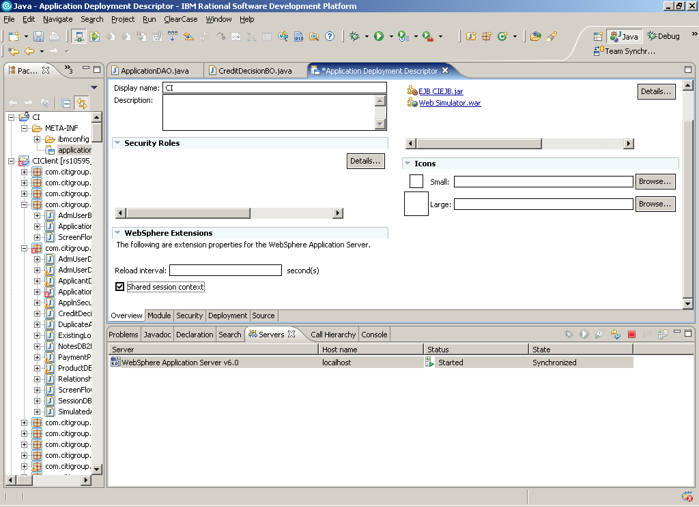

Note:
- If shared HttpSession context is turned on in an enterprise application, HttpSession listeners defined in all the Web modules inside the enterprise application are invoked for session events. The order of listener invocation is not guaranteed.
- To use the option in Websphere for session sharing across contexts, you must install all the Web modules in the enterprise application on a given server. You cannot split up Web modules in the enterprise application by servers. For example, with an enterprise application containing two Web modules, you cannot use this option when one Web module is installed on one server and second Web module is installed on a different server. In such split installations, applications might share session attributes across Web modules using distributed sessions, but session data integrity is lost when concurrent access to a session is made in different Web modules.

WebLogic
You can configure the session descriptor at the application level in the weblogic-application.xml deployment descriptor. To enable Web applications to share the same session, set the sharing-enabled attribute in the session descriptor to true in the weblogic-application.xml deployment descriptor.

<?xml version="1.0" encoding="ISO-8859-1"?>
<weblogic-application xmlns="http://www.bea.com/ns/weblogic/90";;> ...
<session-descriptor>
<persistent-store-type>memory</persistent-store-type>
<sharing-enabled>true</sharing-enabled>
...
</session-descriptor>
...
</weblogic-application>

Note:
- The session descriptor configuration that you specify at the application level overrides any session descriptor configuration that you specify at the Web application level for all of the Web applications in the application.
- All Web applications in an application are automatically started using the same session instance if you specify the session descriptor in the weblogic-application.xml deployment descriptor and set the sharing-enabled attribute to true

NEW FEATURES – SERVLET 2.4

The web.xml file now uses XML Schema instead of DTDs

In previous versions of the servlet specification, the deployment descriptors for servlet web applications were defined and validated using an XML DTD. This worked fine, but as it turned out, DTDs aren't quite modular or flexible enough for other technologies to be able to leverage servlet web apps as a framework.

To achieve this level of flexibility and modularity, those involved in revising the Servlet 2.4 Specification and other J2EE 1.4 specifications decided to base the deployment descriptor definition and validation on the newer XML Schema, while maintaining backwards-compatibility with the older servlet 2.3 (and lower) DTDs.

Upgraded support for HTTP, J2SE, and J2EE
Servlet 2.4 depends on HTTP/1.1 and J2SE 1.3. Previously, servlets relied upon HTTP/1.0 and J2SE 1.2. Some servers already support HTTP/1.1, but those that don't will have to spend some time upgrading.

Request Listener
Servlet 2.3, which is a pervious version of Servlet, introduced the idea of context and session listeners, classes that could observe when a context or session was initialized or about to be destroyed,and when attributes were added or removed to the context or session. Servlet 2.4 expands the model to add request listeners, allowing developers (or more likely tool vendors) to observe as requests are created and destroyed, and as attributes are added.

Filter for Request Dispatcher
In Servlet 2.4, we can specify filters for forward and included requests too. Earlier versions, only supported and filters get intercepted only for requests coming from browser.

Filter can be used for RequestDispatcher , Could be REQUEST, FORWARD, INCLUDE, ERROR or any combination of them.

One of the ambiguous areas in previous version of Servlet is in regard to the interaction between the RequestDispatcher and filters. Should filters invoke for forwarded requests? Included requests? What about for URIs invoked via the <error-page> mechanism? Before Servlet 2.4, these questions were left as open issues. Now Servlet 2.4 makes it a developer's choice.

<filter-mapping>
<filter-name>DispatcherFilter</filter-name>
<url-pattern>/products/*</url-pattern>
<dispatcher>FORWARD</dispatcher>
<dispatcher>REQUEST</dispatcher>
</filter-mapping>
You can add any number of <dispatcher> entries to a <filter-mapping> like above.

SingleThreadedModel
In Servlet 2.4, SingleThreadModel is deprecated for a good reason mostly because it does not really provide thread safety. So, recommendation is avoid the usage of instance variables and if you do, use sychronized code block.

SERVLET FAQ

GenericServlet & HttpServlet
A servlet class can extend javax.servlet.GenericServlet or javax.servlet.HttpServlet. The designers of the original servlet API expected that it would used for a variety of protocols above and beyond simple HTTP, hence the decision to create both a GenericServlet and an HttpServlet class. The GenericServlet class is used for for servlets that don’t implement any particular communication protocol.

getServletInfo
A servlet should implement getServletInfo(), which returns a String that contains information about the servlet, such as name,author and version(just like getAppletInfo() in applets). This method is called by the web server and generally used for logging purposes. It’s rarely implemented in the real world, but it really is good practice to do so.

Why setContentType() should be called before getWriter()
ServletResponse & HttpServletResponse each define two methods for producing output streams, getOutputStream() and getWriter(). The getOutputStream() returns a ServletOutputStream, which can be used for textual or binary data. The getWriter() method examines the content type to determine which charset to use, so setContentType() should be called before getWriter().

init(), init(ServletConfig) & destroy()
The default init(ServletConfig) implementation is not a do-nothing method. So, you should remember to always call the super.init(ServletConfig) method. If you override the parameterless version namely init(), you don’t have to invoke the super class’s method- ther server calls the parameterized version,which calls the parameterless method.

Unlike the init(), the default implementation of destroy() is a do-nothing method, so you don’t have to worry about invoking the superclass’s destroy() method.

public class LifeCycleServlet extends HttpServlet {
public void init(ServletConfig conf) throws ServletException {
super.init(conf);
try {
int timesAccessed = Integer.parseInt(getInitParameter("defaultStart"));
}catch(Exception e) {}
}

public void doGet(HttpServletRequest req,HttpServletResponse resp) throws ServletException,IOException
{
resp.setContentType("text/html");
PrintWriter out = resp.getWriter();
out.println("<html>");
out.println("</html>");
}
public void destroy() {
// super.destroy() ← not needed
System.out.println("Destroy is called");
}
}

Head Request in Servlet

By default, a HEAD request is automatically processed by the HttpServlet.doGet() method using a modified response object that simply counts and discards any characters written to the buffer. If it is necessary to improve the performance of a servlet that is frequently accessed with a HEAD request method, you can override the HttServlet.doHead() method and implement a more efficient algorithm.

Thread Safety

init() : The init() method is guaranteed to be called once per servlet instance, when the servlet is loaded. You don't have to worry about thread safety inside this method, since it is only called by a single thread, and the web server will wait until that thread exits before sending any more threads into your service() method.

